# Setup informix database on Redhat Linux 5.8 with VMWARE

## Add disk space

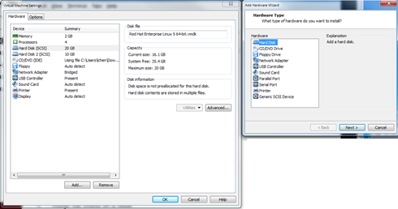  
Type the following to send a rescan request:

# echo "- - -" > /sys/class/scsi_host/host0/scan  
# fdisk -l  
You will find the new added disk.

Partition this new disk

# fdisk /dev/sdb

Format new created partition

# mkfs.ext3 /dev/sdb1

on Redhat Linux, Edit /etc/mtab and /etc/fstab to add this new formatted partition to filesystems

## Share directory on Windows

Install Samba Server on Linux system is a best practice to share a directory between Windows & Linux systems, so you can copy the download software packages from Windows to Linux very conveniently.

To set up a shared folder on Windows for Linux to access, start by making sure your network settings are configured to allow the connection from the other computer by opening the Network and Sharing Center.

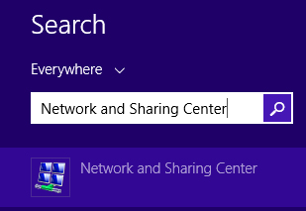

In the Network and Sharing Center window, click on “Change advanced sharing settings.”

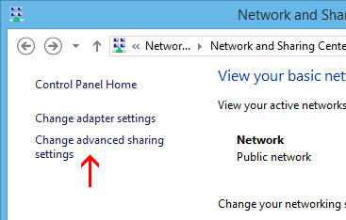

For your current profile, adjust the following two settings:

* Turn on network discovery
* Turn on file and printer sharing

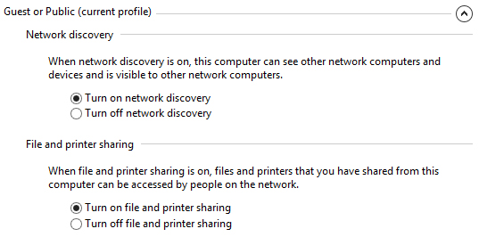

Click on “Save Changes” after those settings are configured. Now we can create a place on the Windows computer for the Linux machine to see files and copy contents to. There are no limitations to what you can share out (you could theoretically share your entire hard drive), but we will just be sharing out a folder called “Share” located on our Desktop.

Right click on the folder you’d like to share out over the network, and click Properties. Go to the Sharing tab and click Advanced Sharing.

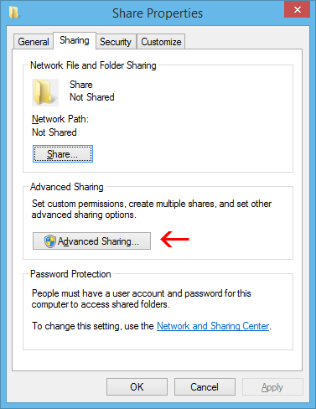

Check the “Share this folder” box and click on “Permissions” toward the bottom.

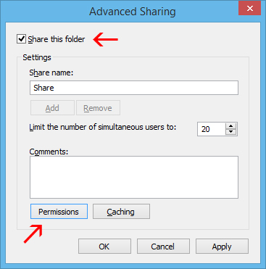

In the Permissions window, you can restrict access to the folder for certain accounts. To let any user have access to your folder, just give Full Control to the Everyone user. This will allow anyone to read and write changes to the shared folder. If you would rather restrict access to certain accounts, just remove the Everyone user and add the users you’d like to grant access to. Note: These user accounts are on the Windows computer, not Linux.

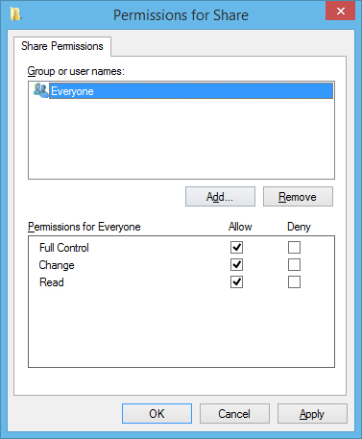

Click OK on the Permissions and Advanced Sharing windows once you’ve made your changes. While still in the Properties menu, click on the Security tab.

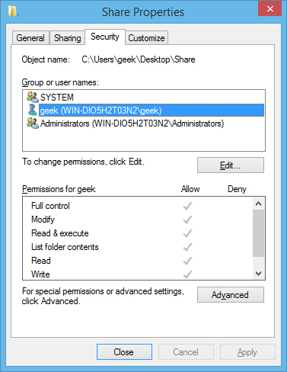

For the Linux user to have access to the shared folder, the same permissions need to be configured in this tab as what we configured in the sharing settings. If the two settings don’t match, the most restrictive settings are the ones that will take effect. If your desired user already has their security permissions set up (such as the geek user in our example) then you’re good to go and can click Close.

If you need to add a user, such as Everyone, click on Edit.

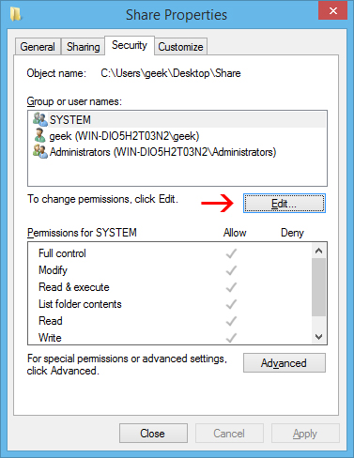

Click on Add in the next menu, enter the username, and click OK.

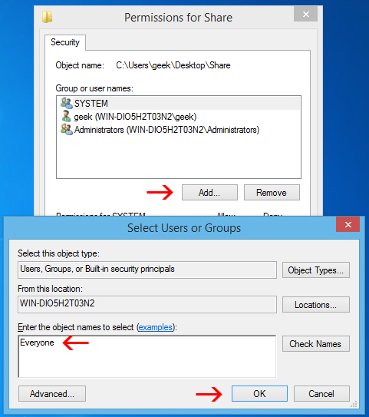

Click OK on all the open windows, and your folder should now be shared out and accessible on your Linux computer.

Accessing the Windows Share from Linux

You should be able to mount the shared folder by using the GUI in Linux, but it’s also very easy to do with the command line, and it’s easier to show a terminal example because it will work across many different distributions.

You’ll need the cifs-utils package in order to mount SMB shares:

# sudo apt-get install cifs-utils

After that, just make a directory and mount the share to it. In this example, we will mount the folder to our Desktop for easy access.

mkdir ~/Desktop/Windows-Share

# sudo mount.cifs //WindowsPC/Share /home/geek/Desktop/Windows-Share -o user=geek

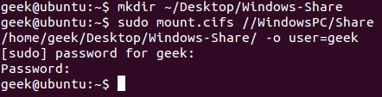

As you can see in the screenshot, we were prompted for the root password of the Linux machine, and then the password for the ‘geek’ account on Windows. After running that command, we are now able to see the contents of the Windows share and add data to it.

In case you need help understanding the mount command, here’s a breakdown:

sudo mount.cifs – This is just the mount command, set to mount a CIFS (SMB) share.

WindowsPC – This is the name of the Windows computer. Type “This PC” into the Start menu on Windows, right click it, and go to Properties to see your computer name.

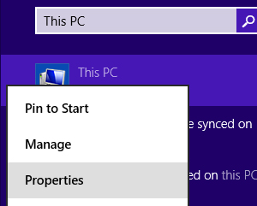

* //Windows-PC/Share – This is the full path to the shared folder.
* /home/geek/Desktop/Windows-Share – This is where we’d like the share to be mounted.
* -o user=geek – This is the Windows username that we are using to access the shared folder.

**Creating the Share on Linux**

To set up a shared folder on Linux for Windows to access, start with installing Samba.

# sudo apt-get install samba

After Samba installs, configure a username and password that will be used to access the share.

# smbpasswd -a geek

Note: In this example, we are using ‘geek’ since we already have a Linux user with that name – but you can choose any name you’d like.

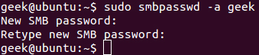

Create the directory that you’d like to share out to your Windows computer. We’re just going to put a folder on our Desktop.

mkdir ~/Desktop/Share

Now, use your favorite editor to configure the smb.conf file.

# sudo vi /etc/samba/smb.conf

Scroll down to the end of the file and add these lines:

[<folder_name>]  
path = /home/<user_name>/<folder_name>  
available = yes  
valid users = <user_name>  
read only = no  
browsable = yes  
public = yes  
writable = yes

Obviously, you’ll need to replace some of the values with your personal settings. It should look something like this:

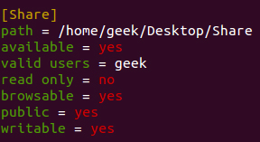

Save the file and close your editor. Now, restart the SMB service for the changes to take effect.

sudo service smbd restart

Your shared folder should now be accessible from a Windows PC.

Accessing the Linux Share from Windows

Now, let’s add the Linux share to our Windows Desktop. Right-click somewhere on your Desktop and go to New > Shortcut.

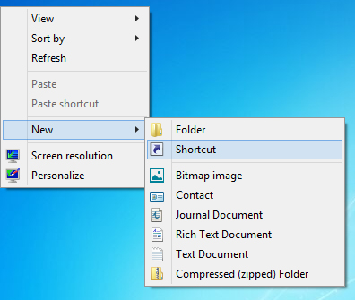

Type in the network location of the shared folder, with this syntax:

\\IP-ADDRESS\SHARE-NAME

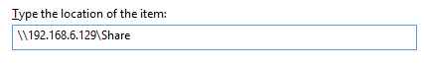

If you need the IP of your Linux computer, just issue the following command:

# ifconfig

Click Next, choose a name for the Shortcut, and click Finish. You should end up with a Shortcut on your Desktop that goes right to the Linux share.

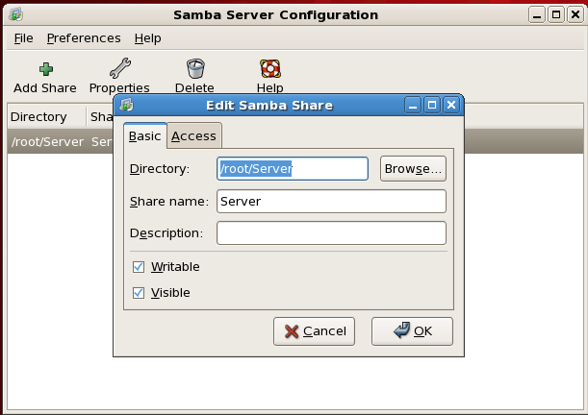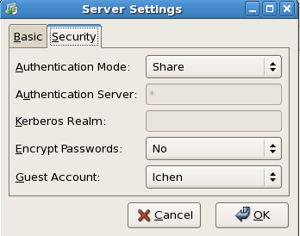

# chmod –R lchen:root /Server

Another way to share Windows Drive (directory) with VMWare Linux Server:

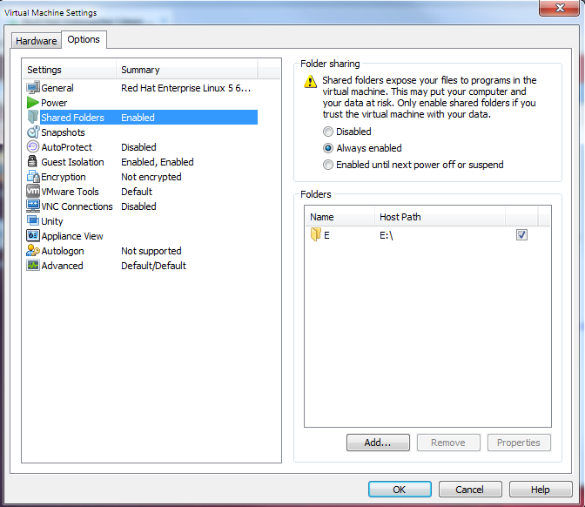

## Install informix 11.7 on RH Linux5.8 64-bit

Create user/group: informix/informix

[root@db2cm64 home]# mkdir informix

[root@db2cm64 home]# chmod -R 755 informix

[root@db2cm64 home]# chown -R informix:informix informix

[root@db2cm64 informix]# cd /Server/informix; ./ids_install

Preparing to install...

Extracting the JRE from the installer archive...

Unpacking the JRE...

Extracting the installation resources from the installer archive...

Configuring the installer for this system's environment...

Launching installer...

Preparing CONSOLE Mode Installation...

===============================================================================

IBM Informix Software Bundle (created with InstallAnywhere)

-------------------------------------------------------------------------------

===============================================================================

Getting started with IBM Informix Software Bundle

-------------------------------------------------

InstallAnywhere will guide you through the installation of IBM Informix

Software Bundle.

Copyright IBM Corporation 1996, 2012. All rights reserved.

1. Release Notes

The Release Notes can be found in

/Server/informix/SERVER/doc/ids_unix_relnotes_11.70.html

2. Installation Guide

Please view the Installation / Quick Beginnings Guide at

/Server/informix/SERVER/doc/ids_unix_installg_11.70.pdf

3. Launch Information Center

Access the IDS 11.70 Information Center at

http://publib.boulder.ibm.com/infocenter/idshelp/v117/index.jsp

To Begin Installation,

Respond to each prompt to proceed to the next step in the installation.

If you want to change something on a previous step, type 'back'.

You may cancel this installation at any time by typing 'quit'.

PRESS <ENTER> TO CONTINUE:

===============================================================================

International License Agreement for Non-Warranted Programs

Part 1 - General Terms

BY DOWNLOADING, INSTALLING, COPYING, ACCESSING, CLICKING ON AN

"ACCEPT" BUTTON, OR OTHERWISE USING THE PROGRAM, LICENSEE AGREES TO

THE TERMS OF THIS AGREEMENT. IF YOU ARE ACCEPTING THESE TERMS ON

BEHALF OF LICENSEE, YOU REPRESENT AND WARRANT THAT YOU HAVE FULL

AUTHORITY TO BIND LICENSEE TO THESE TERMS. IF YOU DO NOT AGREE TO

THESE TERMS,

* DO NOT DOWNLOAD, INSTALL, COPY, ACCESS, CLICK ON AN "ACCEPT" BUTTON,

OR USE THE PROGRAM; AND

* PROMPTLY RETURN THE UNUSED MEDIA AND DOCUMENTATION TO THE PARTY FROM

WHOM IT WAS OBTAINED FOR A REFUND OF THE AMOUNT PAID. IF THE PROGRAM

WAS DOWNLOADED, DESTROY ALL COPIES OF THE PROGRAM.

1. Definitions

Press Enter to continue viewing the license agreement, or enter "1" to

accept the agreement, "2" to decline it, "3" to print it, or "99" to go back

to the previous screen.:

"Authorized Use" - the specified level at which Licensee is authorized

to execute or run the Program. That level may be measured by number of

users, millions of service units ("MSUs"), Processor Value Units

("PVUs"), or other level of use specified by IBM.

"IBM" - International Business Machines Corporation or one of its

subsidiaries.

"License Information" ("LI") - a document that provides information

and any additional terms specific to a Program. The Program's LI is

available at www.ibm.com/software/sla. The LI can also be found in the

Program's directory, by the use of a system command, or as a booklet

included with the Program.

"Program" - the following, including the original and all whole or

partial copies: 1) machine-readable instructions and data, 2)

components, files, and modules, 3) audio-visual content (such as

images, text, recordings, or pictures), and 4) related licensed

Press Enter to continue viewing the license agreement, or enter "1" to

accept the agreement, "2" to decline it, "3" to print it, or "99" to go back

to the previous screen.: 1

===============================================================================

Installation Goals

------------------

What do you want to accomplish?

->1- Install products and features

2- Extract the product files (-DLEGACY option)

3- Create an RPM image for redistribution

ENTER THE NUMBER FOR YOUR CHOICE, OR PRESS <ENTER> TO ACCEPT THE DEFAULT::

===============================================================================

Installation Location

---------------------

Choose location for software installation

Default Install Folder: /opt/IBM/informix

ENTER AN ABSOLUTE PATH, OR PRESS <ENTER> TO ACCEPT THE DEFAULT

:

===============================================================================

Installation Type

-----------------

Select the installation type.

Typical: Install the database server with all features and a database server that

is configured with default values. Includes:

** Client Software Development Kit (CSDK)

** Java Database Connectivity (JDBC)

Minimum disk space required: 700-800MB

Custom: Install the database server with specific features and software that you need.

Optionally install a configured database server instance.

Minimum disk space required: 75 MB (without a server instance)

->1- Typical

2- Custom

ENTER THE NUMBER FOR YOUR CHOICE, OR PRESS <ENTER> TO ACCEPT THE DEFAULT::

===============================================================================

Server Instance Creation

------------------------

Create a server instance?

->1- Yes - create an instance

2- No - do not create an instance

ENTER THE NUMBER FOR YOUR CHOICE, OR PRESS <ENTER> TO ACCEPT THE DEFAULT::

===============================================================================

International License Agreement for Non-Warranted Programs

Part 1 - General Terms

BY DOWNLOADING, INSTALLING, COPYING, ACCESSING, CLICKING ON AN

"ACCEPT" BUTTON, OR OTHERWISE USING THE PROGRAM, LICENSEE AGREES TO

THE TERMS OF THIS AGREEMENT. IF YOU ARE ACCEPTING THESE TERMS ON

BEHALF OF LICENSEE, YOU REPRESENT AND WARRANT THAT YOU HAVE FULL

AUTHORITY TO BIND LICENSEE TO THESE TERMS. IF YOU DO NOT AGREE TO

THESE TERMS,

* DO NOT DOWNLOAD, INSTALL, COPY, ACCESS, CLICK ON AN "ACCEPT" BUTTON,

OR USE THE PROGRAM; AND

* PROMPTLY RETURN THE UNUSED MEDIA AND DOCUMENTATION TO THE PARTY FROM

WHOM IT WAS OBTAINED FOR A REFUND OF THE AMOUNT PAID. IF THE PROGRAM

WAS DOWNLOADED, DESTROY ALL COPIES OF THE PROGRAM.

1. Definitions

Press Enter to continue viewing the license agreement, or enter "1" to

accept the agreement, "2" to decline it, "3" to print it, or "99" to go back

to the previous screen.: 1

===============================================================================

Installation Summary

--------------------

Please review the following before continuing:

Product Name:

IBM Informix Software Bundle

Install Folder:

/opt/IBM/informix

Product Features:

IBM Informix database server,

Base Server,

Extensions and tools,

J/Foundation,

Database extensions,

Conversion and reversion support,

XML publishing,

Demonstration database scripts,

Enterprise Replication,

Data loading utilities,

onunload and onload utilities,

dbload utility,

High-Performance Loader,

Backup and Restore,

archecker utility,

ON-Bar utility,

Informix Storage Manager,

Informix interface to Tivoli Storage Manager,

Administrative utilities,

Performance monitoring utilities,

Miscellaneous monitoring utilities,

Auditing utilities,

Database import and export utilities,

IBM Informix Client SDK,

IBM Informix Object Interface for C++,

IBM Informix Object Interface for C++ demos,

IBM Informix ESQL/C,

7.2 application compatibility module,

IBM Informix ESQL/C demos,

IBM Informix LIBDMI for client applications,

IBM Informix ODBC Driver,

IBM Informix ODBC Driver demos,

Global Language Support (GLS),

West European and Americas,

East European and Slavic,

Japanese,

Korean,

Chinese,

Thai,

IBM Informix JDBC

Server name:

ol_informix1170

Server DRDA alias:

Server number:

0

TCP/IP port number:

16697

Total instance size:

437 MB

Total memory (bufferpool + user):

129 MB

Bufferpool allocation:

97 MB

Number of processors:

1

Data storage location:

/opt/IBM/informix/ol_informix1170/dbspaces

Disk Space Information (for Installation Target):

Required: 1,048,477,120 bytes

Available: 30,246,674,432 bytes

PRESS <ENTER> TO CONTINUE:

===============================================================================

Ready To Install

----------------

InstallAnywhere is now ready to install IBM Informix Software Bundle onto your

system at the following location:

/opt/IBM/informix

PRESS <ENTER> TO INSTALL:

===============================================================================

Installing...

-------------

[==================|==================|==================|==================]

[------------------|------------------|------------------|------------------]

===============================================================================

Server Initialization

---------------------

The server will now be initialized. Initialization might take quite a while,

depending on the performance of your computer.

PRESS <ENTER> TO CONTINUE:

===============================================================================

Using the new instance

----------------------

The IBM Informix Software Bundle created a database server instance. If you

selected to initialize the instance and to display a command prompt, the

instance is ready to use.

If you selected to initialize the instance and chose not to display a command

prompt, you can go to /opt/IBM/informix on a command line and run one of the

following commands, where ol_informix1170 is the name of the path or file where

the instance is installed:

Windows:

ol_informix1170.cmd

UNIX csh:

source ol_informix1170.csh

UNIX ksh or bourne:

./ol_informix1170.ksh

If you selected to initialize the instance and it fails to run, check the

online.log file to verify that initialization was successful.

In addition, if you used an existing configuration file during the

installation, ensure that the root chunk exists, is owned by user and group

informix, and has readable and writable (rw) permission bits set for owner and

group only.

PRESS <ENTER> TO CONTINUE:

===============================================================================

Installation Complete

---------------------

Congratulations! IBM Informix Software Bundle installation is complete.

Product install status:

IBM Informix 11.70: Successful

IBM Informix Client-SDK: Successful

IBM Informix JDBC Driver: Successful

IBM OpenAdmin Tool for Informix: Successful

For more information about using Informix products, see the IBM Informix 11.70

Information Center at

http://publib.boulder.ibm.com/infocenter/idshelp/v117/index.jsp.

PRESS <ENTER> TO EXIT THE INSTALLER:

## Configure Linux System for informix

1. [informix@ibmserver ~]$ cat .bash_profile

# .bash_profile

# Get the aliases and functions

if [ -f ~/.bashrc ]; then

. ~/.bashrc

fi

# User specific environment and startup programs

PATH=$PATH:$HOME/bin

# export PATH

. ~/ol_informix1170.ksh

1. [informix@ibmserver ~]$ cat .netrc

machine ipdev login lchen password admin12

machine ifx01 login lchen password admin12

1. [informix@ibmserver ~]$ tail /etc/services

DB2_db2inst1_2 60002/tcp

DB2_db2inst1_END 60003/tcp

db2c_db2inst1 50000/tcp

CMIC 8084/tcp

ol_informix1170 25337/tcp

dr_informix1170 32300/tcp

ipdbsvc 6800/tcp #New ipdb database instance

ardbsvc 6900/tcp #New ardb database instance

systestdbsvc 6600/tcp # system test database

## Load Tables between two instance/database using unload/load utility

1. Create chunck file for informix dbspace

# mount /ix_dat

# touch /ix_dat/ix_dat.1

# touch /ix_dat/ix_dat.2

# touch /ix_dat/ix_dat.3

# touch /ix_dat/ix_dat.4

# chown –R informix:informix /ix_dat

1. Create a 1G dbspace <datadbs1>

# su – informix

$ onspaces -c -d datadbs1 -p /ix_dat/ix_dat.1 -o 0 -s 1000000

Verifying physical disk space, please wait ...

Space successfully added.

** WARNING ** A level 0 archive of Root DBSpace will need to be done.

1. Add other three 1G chuck file to this datadbs1 dbspace

$ onspaces -a datadbs1 -p /ix_dat/ix_dat.2 -o 0 -s 1000000

Verifying physical disk space, please wait ...

Chunk successfully added.

$ onspaces -a datadbs1 -p /ix_dat/ix_dat.3 -o 0 -s 1000000

Verifying physical disk space, please wait ...

Chunk successfully added.

$ onspaces -a datadbs1 -p /ix_dat/ix_dat.4 -o 0 -s 1000000

Verifying physical disk space, please wait ...

Chunk successfully added.

1. Drop database <sysclrdb> using dbaccess

DROP DATABASE >>

Enter the name of the database you wish to drop.

----------------------- @ol_informix1170 ------- Press CTRL-W for Help --------

sysadmin@ol_informix1170

sysclrdb@ol_informix1170

sysmaster@ol_informix1170

sysuser@ol_informix1170

sysutils@ol_informix1170

Tips: Delete this database, because I will setup a new test database exactly same with production system.

1. Create a new database using dbaccess:

database name: ip_0p

Log: No

CREATE DATABASE >> ip_0p

Enter the name you want to assign to the new database, then press Return.

------------------------------------------------ Press CTRL-W for Help --------

select the dbspace <datadbs1> as this database <ip_0p>’s db2space

Tips: chucks(files) make up dbspace, database resident on dbspaces, and tables, as well as index,routine, etc, resident on database.

1. Create schema on the source production informix server ifx01:

$ dbschema –d ip_0p ip_0p.sql

1. Ftp ip_0p.sql to Linux server db2cm64, and run this sql to setup the database ip_0p for testing

$ dbaccess –d ip_0p.sql

1. On production server ifx01, use dbaccess, unload Table: lii_client, lii_account and client_invoice to files and ftp these files to Linux server db2cm64

ALTER TABLE ip_0p:informix.hs_duty_rate DROP CONSTRAINT u208_791;

UNLOAD TO "/home/lchen/ifx01.lii_client" SELECT * FROM lii_client;

UNLOAD TO "/home/lchen/ifx01.lii_account" SELECT * FROM lii_account;

UNLOAD TO "/home/lchen/ifx01.client_invoice" SELECT * FROM client_invoice;

ALTER TABLE ip_0p:informix.hs_duty_rate ADD CONSTRAINT hs_duty_rate_PK PRIMARY KEY (hsno,hstarifftrtmnt,effdate);

1. On Linux server db2cm64, use dbaccess. load these files to tables:

LOAD FROM "/home/lchen/ifx01.client" INSERT INTO lii_client;

LOAD FROM "/home/lchen/ifx01.account" INSERT INTO lii_account;

LOAD FROM "/home/lchen/ifx01.client_invoice" INSERT INTO client_invoice;

1. Change the database to U log mode(un-buffer), which is the normal database log setting

$ ontape -s -U ip_0p

Tips: Load large file (Table), It is a good idea to change the database log mode to No Log mode

$ ontape -s -N ip_0p

1. Alter a table to turn off/on logging mode

$ dbaccess

ALTER TABLE client_invoice TYPE (RAW)

ALTER TABLE client_invoice TYPE (STANDARD)

## Adjust the size of log files to prevent long transactions

Use larger log files when many users are writing to the logs at the same time. If you use small logs and long transactions are likely to occur, reduce the high-watermark. Set the LTXHWM value to 50 and the LTXEHWM value to 60.

If the log files are too small, the database server might run out of log space while rolling back a long transaction. In this case, the database server cannot block fast enough to add a new log file before the last one fills. If the last log file fills, the system hangs and displays an error message. To fix the problem, shut down and restart the database server.

## Add more tempdbs space to build (set) contrains, indexs for a large table.

$ onspaces -a tempdbs -p /ix_dat/ix_temp.1 -o 0 -s 1000000

Verifying physical disk space, please wait ...

Chunk successfully added.

< Run SQL in $ dbaccess >

SET CONSTRAINTS,INDEXES,TRIGGERS FOR client_invoice ENABLED;

## Load Table between two instance/database using SQL

1. setup the informix environment on Linux Server.

There 3 files you should modify, so you can connect to and run sql on another instance on different servers without prompting for username and password.

# su – informix

$ ls -la

total 28

drwxr-xr-x 2 informix informix 4096 Sep 11 17:13 .

drwxr-xr-x 5 root root 4096 Sep 8 22:42 ..

-rw------- 1 informix informix 326 Sep 11 14:24 .bash_history

-rwxr-xr-x 1 informix informix 259 Sep 8 23:02 .bash_profile

-rw------- 1 informix informix 137 Sep 11 17:13 .netrc

-rw------- 1 informix informix 975 Sep 11 17:13 .viminfo

$ chmod 600 .netrc

$ more .netrc

machine ifx01 login lchen password admini@12

machine ipdev login lchen password admini@12

machine db2cm64 login lchen password admini@12

$ more /opt/IBM/informix/etc/sqlhost.ol_informix1170

ol_informix1170 onsoctcp db2cm64 ol_informix1170

dr_informix1170 drsoctcp db2cm64 dr_informix1170

ipdb onsoctcp ifx01 ipdbsvc

systestdb onsoctcp ipdev systestdbsvc

-bash-3.2$ tail -10 /etc/services

ol_informix1170 8166/tcp

dr_informix1170 15103/tcp

systestdbsvc 6600/tcp

ipdbsvc 6800/tcp

1. Run SQL in $dbaccess

SQL: New Run Modify Use-editor Output Choose Save Info Drop Exit

Run the current SQL statements.

------------ ip_0p@ol_informix1170 ------------- Press CTRL-W for Help --------

INSERT INTO b3

SELECT * FROM [ip_systest@systestdb:informix.b3](mailto:ip_systest@systestdb:informix.b3);

$ onstat –

IBM Informix Dynamic Server Version 11.70.FC5DE -- On-Line (CKPT REQ) (LONGTX) -- Up 00:45:36 -- 173796 Kbytes

Blocked:CKPT LONGTX

$ onstat –m

IBM Informix Dynamic Server Version 11.70.FC5DE -- On-Line (CKPT REQ) (LONGTX) -- Up 00:46:23 -- 173796 Kbytes

Blocked:CKPT LONGTX

Message Log File: /opt/IBM/informix/ol_informix1170.log

09:00:33 Performance Advisory: Based on the current workload, the physical log might be too small to

accommodate the time it takes to flush the buffer pool.

09:00:33 Results: The server might block transactions during checkpoints.

09:00:33 Action: If transactions are blocked during the checkpoint, increase the size of the

physical log to at least 103436 KB.

09:00:33 Performance Advisory: The physical log is too small for automatic checkpoints.

09:00:33 Results: Automatic checkpoints are disabled.

09:00:33 Action: To enable automatic checkpoints, increase the physical log to at least 103436 KB.

09:00:34 Performance Advisory: The physical log is running out of room during checkpoint processing.

09:00:34 Results: Transactions are being blocked until the checkpoint is complete.

09:00:34 Action: Increase the physical log size.

09:00:35 Checkpoint Completed: duration was 1 seconds.

09:00:35 Tue Aug 21 - loguniq 140, logpos 0xa85174, timestamp: 0xc4f7861 Interval: 1313

09:00:35 Maximum server connections 3

09:00:35 Checkpoint Statistics - Avg. Txn Block Time 0.000, # Txns blocked 1, Plog used 11316, Llog used 8661

09:00:36 Logical Log 140 Complete, timestamp: 0xc5227b0.

09:00:37 Logical Log Files are Full -- Backup is Needed

You need to Backup Log Files, change Log Tape device to /dev/null using onmonitor before you do the log backup.

$ export TERM vt200

$ onmonitor

INITIALIZATION: Make desired changes and press ESC to record changes.

Press Interrupt to abort changes. Press F2 or CTRL-F for field-level help.

DISK PARAMETERS

Page Size [ 2] Kbytes Mirror [N]

Tape Dev. [/ix_tmp/tapedev ] Block Size [ 32] Kbytes Total Tape Size [ 0] Kbytes

Log Tape Dev. [/x_tmp/ltapedev ] Block Size [ 32] Kbytes Total Tape Size [ 0] Kbytes Stage Blob [ ]

Root Name [rootdbs ] Root Size [ 200000] Kbytes

Primary Path [/opt/IBM/informix/ol_informix1170/dbspaces/rootdbs ] Root Offset [ 0] Kbytes

Mirror Path [ ] Mirror Offset [ 0] Kbytes

Phy. Log Size [ 30176] Kbytes Log. Log Size [ 10000] Kbytes Number of Logical Logs [ 14]

Enter the log tape device pathname

Tips: You can define Tape Device as above, and then use symbolic link to any device you want to use:

ln –s /dev/null /ix_tmp/tapedev

ln –s /dev/null /ix_tmp/ltapedev

$ ontape -a

Performing automatic backup of logical logs.

Please mount tape 1 on /opt/IBM/informix/ltapedev and press Return to continue ...

Do you want to back up the current logical log? (y/n) y

Read/Write End Of Medium enabled: blocks = 4337

Please label this tape as number 1 in the log tape sequence.

This tape contains the following logical logs:

128 - 142

Program over.

-bash-3.2$ onstat -l

IBM Informix Dynamic Server Version 11.70.FC5DE -- On-Line -- Up 01:07:05 -- 181988 Kbytes

Physical Logging

Buffer bufused bufsize numpages numwrits pages/io

P-1 48 64 30627 565 54.21

phybegin physize phypos phyused %used

2:6325 15088 8266 2376 15.75

Logical Logging

Buffer bufused bufsize numrecs numpages numwrits recs/pages pages/io

L-3 10 32 1701136 67273 3868 25.3 17.4

Subsystem numrecs Log Space used

OLDRSAM 1701128 132793268

HA 8 352

address number flags uniqid begin size used %used

4b840c50 7 U-B---- 134 3:53 4608 4608 100.00

4b840cb8 8 U-B---- 135 3:4661 4608 4608 100.00

4b840d20 3 U-B---- 136 2:53 4608 4608 100.00

4b840d88 4 U-B---- 137 1:2953 4608 4608 100.00

4b840df0 6 U-B---- 138 1:12169 4608 4608 100.00

4b840e58 13 U-B---- 139 1:36043 4608 4608 100.00

4b840ec0 14 U-B---- 140 1:40651 4608 4608 100.00

4b840f28 5 U-B---- 141 1:7561 4608 4608 100.00

4b840f90 9 U-B---- 142 3:9269 4608 4608 100.00

4dddde98 15 U---C-L 143 1:45259 4608 1262 27.39

4dd1ab48 16 A------ 0 1:49867 4608 0 0.00

4b6f9ea8 10 U-B---- 129 3:13877 4608 4608 100.00

4b6f9f10 11 U-B---- 130 3:18485 4608 4608 100.00

4b6f9f78 1 U-B---- 131 1:24475 4608 4608 100.00

4b6fa438 2 U-B---- 132 1:29083 4608 4608 100.00

4b826450 12 U-B---- 133 3:23093 4608 4608 100.00

16 active, 16 total

-bash-3.2$ onstat -m

IBM Informix Dynamic Server Version 11.70.FC5DE -- On-Line -- Up 01:09:43 -- 181988 Kbytes

Message Log File: /opt/IBM/informix/ol_informix1170.log

09:46:41 Logical Log 138 - Backup Started

09:46:41 Logical Log 138 - Backup Completed

09:46:41 Logical Log 139 - Backup Started

09:46:41 Logical Log 139 - Backup Completed

09:46:41 Logical Log 140 - Backup Started

09:46:41 Logical Log 140 - Backup Completed

09:46:41 Logical Log 141 - Backup Started

09:46:41 Logical Log 141 - Backup Completed

09:46:49 Logical Log 142 - Backup Started

09:46:49 Dynamically added log file 16 to DBspace 1

09:46:51 Checkpoint Completed: duration was 0 seconds.

09:46:51 Tue Aug 21 - loguniq 143, logpos 0x2a4, timestamp: 0xc56eecd Interval: 1316

09:46:51 Maximum server connections 3

09:46:51 Checkpoint Statistics - Avg. Txn Block Time 0.000, # Txns blocked 0, Plog used 7252, Llog used 4606

09:46:51 Logical Log 142 - Backup Completed

09:46:53 Long Transaction 0x4b829930 Aborted. Rollback Duration: 2784 Seconds

09:46:54 Logical Log 141 Complete, timestamp: 0xc57db60.

09:46:54 Logical Log 142 Complete, timestamp: 0xc57db60.

How many locks one user thread may hold, and how many write calls the user thread have executed , if more LOCKS are needed:

$onstat –u

$ onstat -c | grep LOCKS

# LOCKS - The initial number of locks when Informix starts.

LOCKS 3000000

Tips: Load large file (Table), It is a good idea to change the database log mode to No Log mode

$ ontape -s -N ip_0p

So I have to do this again, clean the backup device and release disk space first.

$ cat /dev/null > /opt/IBM/informix/tapedev

Disconnect all session from database ip_0p and close this database.

$ ontape –s N ip_0p

Please enter the level of archive to be performed (0, 1, or 2) 0

Archive failed - Error changing logging status - 'ip_0p'. iserrno 107.

Program over.

-bash-3.2$ ontape -s -N ip_0p

Please enter the level of archive to be performed (0, 1, or 2) 0

Please mount tape 1 on /opt/IBM/informix/tapedev and press Return to continue ...

10 percent done.

20 percent done.

30 percent done.

40 percent done.

50 percent done.

60 percent done.

70 percent done.

80 percent done.

100 percent done.

Read/Write End Of Medium enabled: blocks = 36226

Please label this tape as number 1 in the arc tape sequence.

This tape contains the following logical logs:

143

Program over.

Add other three 1G chuck file to logdbs

$ onspaces -a logdbs -p /ix_dat/ix_llog.1 -o 0 -s 1000000

Verifying physical disk space, please wait ...

Chunk successfully added.

$ onparams -a -d logdbs -s 900000 -i

Log operation started. To monitor progress, use the onstat -l command.

Logical log successfully added.

$ onstat -l

IBM Informix Dynamic Server Version 11.70.FC5DE -- On-Line -- Up 01:39:19 -- 181988 Kbytes

Physical Logging

Buffer bufused bufsize numpages numwrits pages/io

P-1 0 64 96094 1687 56.96

phybegin physize phypos phyused %used

2:6325 15088 14363 7 0.05

Logical Logging

Buffer bufused bufsize numrecs numpages numwrits recs/pages pages/io

L-3 0 32 3608414 140850 6284 25.6 22.4

Subsystem numrecs Log Space used

OLDRSAM 3608393 280934956

HA 21 924

address number flags uniqid begin size used %used

4b840c50 7 U------ 150 3:53 4608 4608 100.00

4b840cb8 8 U------ 151 3:4661 4608 4608 100.00

4b840d20 3 U------ 152 2:53 4608 4608 100.00

4b840d88 4 U------ 153 1:2953 4608 4608 100.00

4b840df0 6 U------ 154 1:12169 4608 4608 100.00

4b840e58 13 U------ 155 1:36043 4608 4608 100.00

4b840ec0 14 U------ 156 1:40651 4608 4608 100.00

4b840f28 5 U------ 157 1:7561 4608 4608 100.00

4b840f90 9 U------ 158 3:9269 4608 4608 100.00

4e59c330 17 U---C-L 159 1:63518 4608 887 19.25

4e59c228 19 A------ 0 12:3 450000 0 0.00

4e59c100 18 A------ 0 1:68126 4608 0 0.00

4dddde98 15 U------ 143 1:45259 4608 4608 100.00

4dd1ab48 16 U------ 144 1:49867 4608 4608 100.00

4b6f9ea8 10 U------ 145 3:13877 4608 4608 100.00

4b6f9f10 11 U------ 146 3:18485 4608 4608 100.00

4b6f9f78 1 U------ 147 1:24475 4608 4608 100.00

4b6fa438 2 U------ 148 1:29083 4608 4608 100.00

4b826450 12 U------ 149 3:23093 4608 4608 100.00

19 active, 19 total

$ onstat -d

IBM Informix Dynamic Server Version 11.70.FC5DE -- On-Line -- Up 01:40:13 -- 181988 Kbytes

Dbspaces

address number flags fchunk nchunks pgsize flags owner name

4b6fa028 1 0x60001 1 1 2048 N BA informix rootdbs

4b826558 2 0x40001 2 1 2048 N BA informix physdbs

4b826700 3 0x60001 3 2 2048 N BA informix logdbs

4b8268a8 4 0x40001 4 1 2048 N BA informix datadbs

4b826a50 5 0x48001 5 1 2048 N SBA informix sbspace

4b826bf8 6 0x42001 6 2 2048 N TBA informix tempdbs

4b826da0 7 0x40001 7 4 2048 N BA informix datadbs1

7 active, 2047 maximum

Chunks

address chunk/dbs offset size free bpages flags pathname

4b6fa1d0 1 1 0 100000 39805 PO-B-- /opt/IBM/informix/ol_informix1170/dbspaces/rootdbs

4b6fa4a0 2 2 0 25088 5339 PO-B-- /opt/IBM/informix/ol_informix1170/dbspaces/plogdbs

4b6fa6a0 3 3 0 30720 3019 PO-B-- /opt/IBM/informix/ol_informix1170/dbspaces/llogdbs

4b6fa8a0 4 4 0 25600 25547 PO-B-- /opt/IBM/informix/ol_informix1170/dbspaces/datadbs

4b6faaa0 5 5 0 16384 15205 15205 POSB-- /opt/IBM/informix/ol_informix1170/dbspaces/sbspace

Metadata 1126 837 1126

4b6faca0 6 6 0 25600 25547 PO-B-- /opt/IBM/informix/ol_informix1170/dbspaces/tempdbs

4d709028 7 7 0 500000 0 PO-B-- /ix_dat/ix_dat.1

4d709228 8 7 0 500000 405789 PO-B-- /ix_dat/ix_dat.2

4d709428 9 7 0 500000 499997 PO-B-- /ix_dat/ix_dat.3

4d709628 10 7 0 500000 499997 PO-B-- /ix_dat/ix_dat.4

4d709828 11 6 0 500000 499997 PO-B-- /ix_dat/ix_temp.1

4dd1abb0 12 3 0 500000 49997 PO-B-- /ix_dat/ix_llog.1

12 active, 32766 maximum

NOTE: The values in the "size" and "free" columns for DBspace chunks are

displayed in terms of "pgsize" of the DBspace to which they belong.

Expanded chunk capacity mode: always

Again!!!

-bash-3.2$ touch ix_llog.2

-bash-3.2$ ls -l

total 6005920

-rw-rw---- 1 informix informix 1024000000 Aug 21 10:42 ix_dat.1

-rw-rw---- 1 informix informix 1024000000 Aug 21 10:42 ix_dat.2

-rw-rw---- 1 informix informix 1024000000 Aug 17 10:36 ix_dat.3

-rw-rw---- 1 informix informix 1024000000 Aug 17 10:36 ix_dat.4

-rw-rw---- 1 informix informix 1024000000 Aug 21 10:44 ix_llog.1

-rw-rw-r-- 1 informix informix 0 Aug 21 10:44 ix_llog.2

-rw-rw---- 1 informix informix 1024000000 Aug 21 08:40 ix_temp.1

drw-rw---- 2 informix informix 16384 Aug 17 09:38 lost+found

-bash-3.2$ chmod 660 ix_llog.2

-bash-3.2$ ls -l

total 6005920

-rw-rw---- 1 informix informix 1024000000 Aug 21 10:44 ix_dat.1

-rw-rw---- 1 informix informix 1024000000 Aug 21 10:44 ix_dat.2

-rw-rw---- 1 informix informix 1024000000 Aug 17 10:36 ix_dat.3

-rw-rw---- 1 informix informix 1024000000 Aug 17 10:36 ix_dat.4

-rw-rw---- 1 informix informix 1024000000 Aug 21 10:44 ix_llog.1

-rw-rw---- 1 informix informix 0 Aug 21 10:44 ix_llog.2

-rw-rw---- 1 informix informix 1024000000 Aug 21 08:40 ix_temp.1

drw-rw---- 2 informix informix 16384 Aug 17 09:38 lost+found

-bash-3.2$ onspaces -a logdbs -p /ix_dat/ix_llog.2 -o 0 -s 1000000

Verifying physical disk space, please wait ...

Chunk successfully added.

-bash-3.2$ onparams -a -d logdbs -s 999900 -i

Log operation started. To monitor progress, use the onstat -l command.

Logical log successfully added.

$ dbaccess

SQL: New Run Modify Use-editor Output Choose Save Info Drop Exit

Run the current SQL statements.

------------ ip_0p@ol_informix1170 ------------- Press CTRL-W for Help --------

INSERT INTO b3

SELECT * FROM ip_systest@systestdb:informix.b3

WHERE EXTEND(TO_DATE(approveddate,"%Y/%m/%d %H:%M:%S"),YEAR TO SECOND) <

(EXTEND(current, YEAR TO SECOND) - INTERVAL(1) YEAR TO YEAR - INTERVAL(7) MONTH TO MONTH);

Using TEMP table to guarantee the Data insert into archive DB is exactly the same with the data deleted from the original production resource table

To disable logging on temporary tables, set the TEMPTAB_NOLOG configuration parameter to 1.

# TEMPTAB_NOLOG - Controls the default logging mode for temporary

TEMPTAB_NOLOG 0

$ onmode -wf TEMPTAB_NOLOG=1

17:01:52 Value of TEMPTAB_NOLOG has been changed to 1.

$ onmode -wm TEMPTAB_NOLOG=1

17:02:00 Value of TEMPTAB_NOLOG has been changed to 1.

$ dbaccess

SQL: New Run Modify Use-editor Output Choose Save Info Drop Exit

Run the current SQL statements.

------------ ip_0p@ol_informix1170 ------------- Press CTRL-W for Help --------

SELECT * FROM ip_systest@systestdb:informix.b3

WHERE EXTEND(TO_DATE(approveddate,"%Y/%m/%d %H:%M:%S"),YEAR TO SECOND) >

(EXTEND(current, YEAR TO SECOND) - INTERVAL(1) YEAR TO YEAR - INTERVAL(7) MONTH TO MONTH)

INTO TEMP tmp_b3;

INSERT INTO b3 SELECT * FROM tmp_b3 t_b3

WHERE t_b3.b3iid NOT EXSITS (SELECT b3iid FROM b3);

DELETE FROM [ip_systest@systestdb:informix.b3](mailto:ip_systest@systestdb:informix.b3) o_b3

WHERE o_b3.b3iid IN (SELECT b3iid FROM tmp_b3);

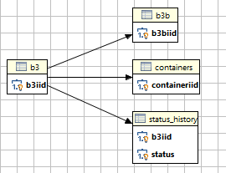

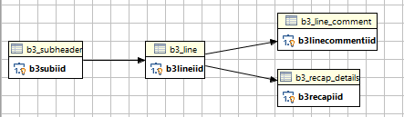

b3: 3,021,376,578 byte

b3b: 1,070,955 byte

containers: 2,682,988 byte

status_history: 698,664,792 byte

b3_subheader: 715,614,824 byte

b3_line: 14,957,060,547 byte

b3_line_comment: 471,820 byte

b3_recap_details: 6,377,817,173 byte

TIPS: Add more io vp to tuning the IO performance

$ onmode –p +10 io

$ onmode –p +10 cpu

## When Using TEMP table, Add more tempdbs space

Firstly, Delete formal chunck, only because demo license version cannot support so many chuncks.

-bash-3.2$ onspaces -d tempdbs -p /ix_tmp/ix_temp.1 -o 0

WARNING: Dropping a chunk.

Do you really want to continue? (y/n)y

Chunk successfully dropped.

** WARNING ** A level 0 archive for DBspace tempdbs will need to be done

before '/ix_dat/ix_temp.1' can be reused (see Dynamic Server Administrator's manual).

$ cat /dev/null > /ix_tmp/ix_temp.1

$ onspaces -a tempdbs -p /ix_tmp/ix_temp.1 -o 0 -s 4000000

Verifying physical disk space, please wait ...

Chunk successfully added.

$dbaccess

SET CONSTRAINTS,INDEXES,TRIGGERS FOR b3b DISABLED;

SET CONSTRAINTS,INDEXES,TRIGGERS FOR containers DISABLED;

SET CONSTRAINTS,INDEXES,TRIGGERS FOR status_history DISABLED;

SET CONSTRAINTS,INDEXES,TRIGGERS FOR b3 DISABLED;

Then, we drop the primary key definition from b3, and we turn off the table log of b3:

$ dbaccess

DROP INDEX <>;

ALTER TABLE b3 DROP CONSTRAINT <>

ALTER TABLE b3 TYPE (RAW)

SELECT * FROM ip_systest@systestdb:informix.b3

WHERE EXTEND(TO_DATE(approveddate,"%Y/%m/%d %H:%M:%S"),YEAR TO SECOND) >

(EXTEND(current, YEAR TO SECOND) - INTERVAL(1) YEAR TO YEAR - INTERVAL(7) MONTH TO MONTH)

INTO TEMP tmp_b3;

INSERT INTO b3 SELECT * FROM tmp_b3

CREATE INDEX <> ON b3 (b3iid);

ALTER TABLE b3 ADD CONSTRAINT primary key (b3iid);

Table altered.

SET CONSTRAINTS,INDEXES,TRIGGERS FOR b3 ENABLED;

SET CONSTRAINTS,INDEXES,TRIGGERS FOR status_history ENABLED;

SET CONSTRAINTS,INDEXES,TRIGGERS FOR containers ENABLED;

SET CONSTRAINTS,INDEXES,TRIGGERS FOR b3b ENABLED;

ALTER TABLE b3 TYPE (standard)

alter table "informix".containers add constraint (foreign key

(b3iid) references "informix".b3 );

alter table "informix".containers add b3b (foreign key

(b3iid) references "informix".b3 );

alter table "informix".containers add status_history (foreign key

(b3iid) references "informix".b3 );

After I load data from Add Primary key CONSTRAINT to TABLE b3 column (b3iid);

$ dbaccess

SQL: New Run Modify Use-editor Output Choose Save Info Drop Exit

Run the current SQL statements.

------------ ip_0p@ol_informix1170 ------------- Press CTRL-W for Help --------

SELECT * FROM ip_systest@systestdb:informix.b3

WHERE EXTEND(TO_DATE(approveddate,"%Y/%m/%d %H:%M:%S"),YEAR TO SECOND) <

(EXTEND(current, YEAR TO SECOND) - INTERVAL(1) YEAR TO YEAR - INTERVAL(7) MONTH TO MONTH)

INTO TEMP tmp_b3;

option

SELECT * FROM ip_systest@systestdb:informix.b3

WHERE approveddate >= '2011/03/01' and approveddate < '2011/04/01'

INTO TEMP tmp_b3;

option

DELETE FROM b3 WHERE b3iid IN (SELECT b3iid FROM tmp_b3)

180162 row(s) deleted.

To solve log files space issue:

$ onstat -c | grep LTX

# LTXHWM - The percentage of the logical logs that can be

# LTXEHWM - The percentage of the logical logs that have been

# LTXHWM and LTXEHWM because the server can add new logical logs

# If dynamic logging is off, set LTXHWM and LTXEHWM to

# When using Enterprise Replication, set LTXEHWM to at least 30%

# higher than LTXHWM to minimize log overruns.

LTXHWM 70

LTXEHWM 80

$ onmode -wm LTXEHWM=100

09:58:27 Value of LTXEHWM has been changed to 100.

$ onmode -wf LTXEHWM=100

09:58:37 Value of LTXEHWM has been changed to 100.

$ onmode -wm LTXHWM=100

09:58:52 Value of LTXHWM has been changed to 100.

$ onmode -wf LTXHWM=100

09:58:58 Value of LTXHWM has been changed to 100.

## Turn on database ip_0p log mode

$ ontape -s -U ip_0p

Please enter the level of archive to be performed (0, 1, or 2) 0

Please mount tape 1 on /ix_tmp/tapedev and press Return to continue ...

10 percent done.

20 percent done.

30 percent done.

40 percent done.

50 percent done.

60 percent done.

70 percent done.

80 percent done.

90 percent done.

100 percent done.

Read/Write End Of Medium enabled: blocks = 134992

Please label this tape as number 1 in the arc tape sequence.

This tape contains the following logical logs:

17

Program over.

$dbaccess

SQL: New Run Modify Use-editor Output Choose Save Info Drop Exit

Run the current SQL statements.

------------ ip_0p@ol_informix1170 ------------- Press CTRL-W for Help --------

SELECT * FROM ip_systest@systestdb:informix.b3

WHERE EXTEND(TO_DATE(approveddate,"%Y/%m/%d %H:%M:%S"),YEAR TO SECOND) <

(EXTEND(current, YEAR TO SECOND) - INTERVAL(1) YEAR TO YEAR - INTERVAL(7) MONTH TO MONTH)

INTO TEMP tmp_b3;

INSERT INTO b3 SELECT * FROM tmp_b3 WHERE b3iid NOT IN (select b3iid from b3);

180162 row(s) inserted.

INSERT INTO b3b SELECT * FROM [ip_systest@systestdb:informix.b3b](mailto:ip_systest@systestdb:informix.b3b)

INSERT INTO containers SELECT * FROM ip_systest@systestdb:informix.containers

INSERT INTO status_history SELECT * FROM [ip_systest@systestdb:informix.status_history](mailto:ip_systest@systestdb:informix.status_history)

INSERT INTO containers SELECT * FROM ip_systest@systestdb:informix.containers

WHERE b3iid NOT IN (SELECT b3iid from containers)

## Insert large table piece by piece using rowid

$dbaccess

SQL: New Run Modify Use-editor Output Choose Save Info Drop Exit

Run the current SQL statements.

------------ ip_0p@ol_informix1170 ------------- Press CTRL-W for Help --------

insert into b3 select * from ip_systest@systestdb:informix.b3

where rowid >5000000 and rowid < 15000000

create trigger "informix".td_b3 delete on "informix".b3 referencing old as old_del for each row

(

execute procedure "informix".pd_b3(old_del.b3iid ));

create procedure "informix".pd_b3(old_b3iid integer)

define errno integer;

define errmsg char(255);

define numrows integer;

-- Delete all children in "b3_subheader"

delete from b3_subheader

where b3iid = old_b3iid;

-- Delete all children in "b3b"

delete from b3b

where b3iid = old_b3iid;

-- Delete all children in "status_history"

delete from status_history

where b3iid = old_b3iid;

-- Delete all children in "containers"

delete from containers

where b3iid = old_b3iid;

end procedure;

create procedure "informix".pd_b3_subheader(old_b3subiid integer)

define errno integer;

define errmsg char(255);

define numrows integer;

-- Delete all children in "b3_line"

delete from b3_line

where b3subiid = old_b3subiid;

end procedure;

create procedure "informix".pd_b3_line(old_b3lineiid integer)

define errno integer;

define errmsg char(255);

define numrows integer;

-- Delete all children in "b3_recap_details"

delete from b3_recap_details

where b3lineiid = old_b3lineiid;

-- Delete all children in "b3_line_comment"

delete from b3_line_comment

where b3lineiid = old_b3lineiid;

end procedure;

create procedure "informix".pd_rpt_b3(old_b3iid integer)

define errno integer;

define errmsg char(255);

define numrows integer;

-- Delete all children in "rpt_b3_subheader"

delete from rpt_b3_subheader

where b3iid = old_b3iid;

end procedure;

create procedure "informix".pi_b3(new_liiclientno integer,

new_liiaccountno integer)

define errno integer;

define errmsg char(255);

define numrows integer;

-- Parent "lii_account" must exist when inserting a child in "b3"

if new_liiclientno is not null and

new_liiaccountno is not null then

select count(*)

into numrows

from lii_account

where liiclientno = new_liiclientno

and liiaccountno = new_liiaccountno;

if (numrows = 0) then

let errno = -1002;

let errmsg = "Parent does not exist in ""lii_account"". Cannot create child in ""b3"".";

raise exception -746, 0, errmsg;

end if;

end if;

end procedure;

create procedure "informix".pi_b3b(new_b3iid integer)

define errno integer;

define errmsg char(255);

define numrows integer;

-- Parent "b3" must exist when inserting a child in "b3b"

if new_b3iid is not null then

select count(*)

into numrows

from b3

where b3iid = new_b3iid;

if (numrows = 0) then

let errno = -1002;

let errmsg = "Parent does not exist in ""b3"". Cannot create child in ""b3b"".";

raise exception -746, 0, errmsg;

end if;

end if;

end procedure;

Synchronize tables between production table with development table, which has a unique constraint with two column

$dbaccess

SQL: New Run Modify Use-editor Output Choose Save Info Drop Exit

Run the current SQL statements.

----------------------- ip_systest@systestdb --- Press CTRL-W for Help --------

insert into lii_client select * from [ip_0p@ipdb:informix.lii_client](mailto:ip_0p@ipdb:informix.lii_client)

where liiclientno NOT IN (select liiclient from lii_client);

insert into lii_account select * from ip_0p@ipdb:informix.lii_account r

where (select count(*) from lii_account l

where r.liiclientno=l.liiclientno and r.liiaccountno=l.liiaccountno)

= 0;

## Archive and Purge B3 Table

$dbaccess

------------ ip_0p@ol_informix1170 ------------- Press CTRL-W for Help --------

drop procedure archiveandpurge()

------------ ip_0p@ol_informix1170 ------------- Press CTRL-W for Help --------

drop PROCEDURE insertarch

-bash-3.2$ dbaccess ip_0p@ol_informix1170 < insertarch.sql

-bash-3.2$ dbaccess ip_0p@ol_informix1170 < archiveandpurge.sql

Database selected.

Routine created.

Database closed.

------------ ip_0p@ol_informix1170 ------------- Press CTRL-W for Help --------

CREATE PROCEDURE "informix".archiveandpurge() RETURNING CHAR(20), CHAR(20), INT;

--Define Working variables

DEFINE startdate CHAR(20);

DEFINE enddate CHAR(20);

DEFINE archivecount INT;

DEFINE archiveDay DATE;

LET startdate = EXTEND(current, YEAR TO MONTH) - INTERVAL(1) YEAR TO YEAR - INTERVAL(7) MONTH TO MONTH;

LET enddate = EXTEND(current, YEAR TO MONTH) - INTERVAL(1) YEAR TO YEAR - INTERVAL(6) MONTH TO MONTH;

LET archiveDay = TODAY;

EXECUTE PROCEDURE insertArch(startdate, enddate);

SELECT COUNT(*)

INTO archivecount

FROM reporterr

WHERE currentday = archiveDay;

IF archivecount = 0 THEN

-- EXECUTE PROCEDURE deleteB3(startdate, enddate);

END IF

RETURN startdate, enddate, archivecount;

END PROCEDURE;

CREATE PROCEDURE "informix".insertarch(startdate CHAR(20),enddate CHAR(20))

-- Declare b3 table columns

DEFINE s_b3iid INT;

DEFINE s_liiclientno INT;

DEFINE s_liiaccountno INT;

DEFINE s_liibrchno INT;

DEFINE s_liirefno INT;

DEFINE s_acctsecurno INT;

DEFINE s_b3type CHAR(2);

DEFINE s_cargcntrlno CHAR(25);

DEFINE s_carriercode CHAR(4);

DEFINE s_createdate CHAR(20);

DEFINE s_custoff CHAR(4);

DEFINE s_k84date CHAR(20);

DEFINE s_modetransp CHAR(2);

DEFINE s_portunlading CHAR(4);

DEFINE s_reldate CHAR(20);

DEFINE s_status INT;

DEFINE s_totb3duty float;

DEFINE s_totb3exctax float;

DEFINE s_totb3gst float;

DEFINE s_totb3sima float;

DEFINE s_totb3vfd float;

DEFINE s_transno INT;

DEFINE s_weight INT;

DEFINE s_purchaseorder1 CHAR(15);

DEFINE s_purchaseorder2 CHAR(15);

DEFINE s_shipvia CHAR(18);

DEFINE s_locationofgoods CHAR(17);

DEFINE s_containerno CHAR(20);

DEFINE s_vendorname CHAR(25);

DEFINE s_vendorstate CHAR(3);

DEFINE s_vendorzip CHAR(10);

DEFINE s_freight float;

DEFINE s_usportexit CHAR(5);

DEFINE s_billoflading CHAR(10);

DEFINE s_cargcntrlqty float;

DEFINE s_approveddate CHAR(20);

--Define Working variables

DEFINE tableName CHAR(25);

DEFINE currentDay DATE;

DEFINE mode CHAR(1);

DEFINE sqlErr INT;

DEFINE isamErr INT;

-- Trap Exception

ON EXCEPTION SET sqlErr, isamErr

CALL reportErr(currentDay,tableName,mode, s_b3iid, sqlErr,isamErr);

END EXCEPTION WITH RESUME;

SET LOCK MODE TO WAIT 60;

LET currentDay = today;

LET tableName = 'B3';

LET mode = 'I';

LET s_b3iid = NULL;

FOREACH WITH HOLD

SELECT b3iid, liiclientno, liiaccountno, liibrchno, liirefno, acctsecurno, b3type,

cargcntrlno, carriercode, createdate, custoff, k84date, modetransp,

portunlading, reldate, status, totb3duty, totb3exctax, totb3gst,

totb3sima, totb3vfd, transno, weight, purchaseorder1, purchaseorder2,

shipvia, locationofgoods, containerno, vendorname, vendorstate, vendorzip,

freight, usportexit, billoflading, cargcntrlqty, approveddate

INTO s_b3iid, s_liiclientno, s_liiaccountno, s_liibrchno, s_liirefno, s_acctsecurno

,

s_b3type, s_cargcntrlno, s_carriercode, s_createdate, s_custoff, s_k84date,

s_modetransp, s_portunlading, s_reldate, s_status, s_totb3duty,

s_totb3exctax, s_totb3gst, s_totb3sima, s_totb3vfd, s_transno, s_weight,

s_purchaseorder1, s_purchaseorder2, s_shipvia, s_locationofgoods, s_containerno,

s_vendorname, s_vendorstate, s_vendorzip, s_freight, s_usportexit,

s_billoflading, s_cargcntrlqty, s_approveddate

FROM ip_0p@ipdb:informix.b3

-- WHERE approveddate >= '2011/03' and approveddate < '2011/04'

WHERE approveddate >= startdate and approveddate < enddate

BEGIN

-- Trap Exception

ON EXCEPTION SET sqlErr, isamErr

CALL reportErr(currentDay,tableName,mode, s_b3iid, sqlErr,isamErr);

END EXCEPTION WITH RESUME;

insert into b3

values(s_b3iid, s_liiclientno, s_liiaccountno, s_liibrchno, s_liirefno, s_acctsecurn

o,

s_b3type, s_cargcntrlno, s_carriercode, s_createdate, s_custoff, s_k84date,

s_modetransp, s_portunlading, s_reldate, s_status, s_totb3duty,

s_totb3exctax, s_totb3gst, s_totb3sima, s_totb3vfd, s_transno, s_weight,

s_purchaseorder1, s_purchaseorder2, s_shipvia, s_locationofgoods, s_containerno,

s_vendorname, s_vendorstate, s_vendorzip, s_freight, s_usportexit,

s_billoflading, s_cargcntrlqty, s_approveddate);

END

END FOREACH;

END PROCEDURE;

------------ ip_0p@ol_informix1170 ------------- Press CTRL-W for Help --------

select count(*) from ip_0p@ipdb:informix.b3

where approveddate like "2011/04/%"

(count(*))

275047

------------ ip_0p@ol_informix1170 ------------- Press CTRL-W for Help --------

execute procedure insertarch(‘2011/03’,’2011/04’)

-bash-3.2$ cd /home/informix/scripts/local/b3_arch

-bash-3.2$ . ./autoArchive.ksh

Database selected.

(expression) (expression) (expression)

2011/02/01 00:00:00 2011/03/01 00:00:00 1

1 row(s) retrieved.

Database closed.

You have mail in /var/spool/mail/root

[lchen@ifx01 /home/lchen] $ lspv

hdisk2 00ca32fde4198d51 livedbvg active

hdisk3 00ca32fde4198fc0 archdbvg active

hdisk4 00ca32fde41a128f appsvg active

hdisk0 00ca32fd35a97b39 rootvg active

hdisk1 00ca32fd35a97d46 rootvg active

[lchen@ifx01 /home/lchen] $ lsvg archdbvg

VOLUME GROUP: archdbvg VG IDENTIFIER: 00ca32fd00004c00000001101750a843

VG STATE: active PP SIZE: 256 megabyte(s)

VG PERMISSION: read/write TOTAL PPs: 399 (102144 megabytes)

MAX LVs: 256 FREE PPs: 4 (1024 megabytes)

LVs: 9 USED PPs: 395 (101120 megabytes)

OPEN LVs: 9 QUORUM: 2 (Enabled)

TOTAL PVs: 1 VG DESCRIPTORS: 2

STALE PVs: 0 STALE PPs: 0

ACTIVE PVs: 1 AUTO ON: yes

MAX PPs per VG: 32512

MAX PPs per PV: 1016 MAX PVs: 32

LTG size (Dynamic): 256 kilobyte(s) AUTO SYNC: no

HOT SPARE: no BB POLICY: relocatable

PV RESTRICTION: none

[lchen@ifx01 /home/lchen] $ lsvg -l archdbvg

archdbvg:

LV NAME TYPE LPs PPs PVs LV STATE MOUNT POINT

achrootlv jfs2 1 1 1 open/syncd /ach_root

achploglv jfs2 1 1 1 open/syncd /ach_plog

achlloglv jfs2 4 4 1 open/syncd /ach_llog

achdat1lv jfs2 172 172 1 open/syncd /ach_dat1

achdat2lv jfs2 184 184 1 open/syncd /ach_dat2

achidx1lv jfs2 12 12 1 open/syncd /ach_idx1

achidx2lv jfs2 12 12 1 open/syncd /ach_idx2

achtemplv jfs2 8 8 1 open/syncd /ach_temp

loglv01 jfs2log 1 1 1 open/syncd N/A

[lchen@ifx01 /home/lchen] $ df -k

Filesystem 1024-blocks Free %Used Iused %Iused Mounted on

/dev/hd4 2883584 2641184 9% 11947 2% /

/dev/hd2 8126464 5121204 37% 71000 6% /usr

/dev/hd9var 3145728 566632 82% 10547 8% /var

/dev/hd3 5242880 4290560 19% 203 1% /tmp

/dev/hd1 2621440 2140584 19% 2275 1% /home

/proc - - - - - /proc

/dev/hd10opt 7864320 7178244 9% 11894 1% /opt

/dev/ibmlv 10485760 10187912 3% 3564 1% /ibm

/dev/achrootlv 262144 11776 96% 5 1% /ach_root

/dev/netinslv 2621440 2620700 1% 4 1% /netins

/dev/dmqjtmplv 13107200 3334044 75% 1735 1% /dmqjtmp

/dev/recyclelv 15728640 6690080 58% 6064 1% /recyclebox

/dev/achlloglv 1048576 48088 96% 5 1% /ach_llog

/dev/achdat1lv 45088768 1081536 98% 48 1% /ach_dat1

/dev/achdat2lv 48234496 226784 100% 52 1% /ach_dat2

/dev/achidx1lv 3145728 144920 96% 7 1% /ach_idx1

/dev/achidx2lv 3145728 144920 96% 7 1% /ach_idx2

/dev/achtemplv 2097152 72504 97% 6 1% /ach_temp

/dev/appslv 10485760 6351088 40% 20368 2% /usr/apps

/dev/achploglv 262144 11776 96% 5 1% /ach_plog

/dev/ixrootlv 262144 46576 83% 5 1% /ix_root

/dev/ixploglv 262144 5776 98% 5 1% /ix_plog

/dev/ixlloglv 1048576 48280 96% 5 1% /ix_llog

/dev/ixdat1lv 23068672 1064760 96% 26 1% /ix_dat1

/dev/ixdat2lv 26214400 1209968 96% 29 1% /ix_dat2

/dev/ixdat3lv 19922944 919572 96% 23 1% /ix_dat3

/dev/ixidx1lv 7340032 338556 96% 11 1% /ix_idx1

/dev/ixidx2lv 5242880 241732 96% 9 1% /ix_idx2

/dev/ixidx3lv 4194304 193336 96% 8 1% /ix_idx3

/dev/ixtemplv 4194304 193336 96% 8 1% /ix_temp

/dev/insightlv 2097152 1987312 6% 3050 1% /insight

/dev/livedump 262144 261776 1% 4 1% /var/adm/ras/livedump

/dev/hd11admin 524288 523864 1% 5 1% /admin

Dbspaces

address number flags fchunk nchunks pgsize flags owner name

50431810 1 0x1 1 1 4096 N informix rootdbs

5051dd50 2 0x1 2 1 4096 N informix llogdbs

5051deb0 3 0x1 3 2 4096 N informix tempdbs1

5138a018 4 0x1 4 1 4096 N informix plogdbs

5138a178 5 0x1 5 44 4096 N informix datadbs1

5138a2d8 6 0x1 27 48 4096 N informix datadbs2

5138a438 7 0x1 51 3 4096 N informix indxdbs1

5138a598 8 0x1 54 3 4096 N informix indxdbs2

< 51390928 52 7 0 250000 1698 PO-- /ach_idx1/ach_idx1.2

< 51390af8 53 7 0 250000 249997 PO-- /ach_idx1/ach_idx1.3

< 51390cc8 54 8 0 250000 177497 PO-- /ach_idx2/ach_idx2.1

---

> 51390928 52 7 0 250000 162 PO-- /ach_idx1/ach_idx1.2

> 51390af8 53 7 0 250000 245901 PO-- /ach_idx1/ach_idx1.3

> 51390cc8 54 8 0 250000 176857 PO-- /ach_idx2/ach_idx2.1

117,119c117,119

< 51399928 100 6 0 250000 182409 PO-- /ach_dat2/ach_dat2.47

< 51399af8 101 6 0 250000 249997 PO-- /ach_dat2/ach_dat2.48

< 51399cc8 102 5 0 250000 211597 PO-- /ach_dat1/ach_dat1.43

---

> 51399928 100 6 0 250000 34945 PO-- /ach_dat2/ach_dat2.47

> 51399af8 101 6 0 250000 184461 PO-- /ach_dat2/ach_dat2.48

> 51399cc8 102 5 0 250000 45709 PO-- /ach_dat1/ach_dat1.43

INFO - b3: Columns Indexes Privileges References Status cOnstraints triGgers Table Fragments Exit

Display fragment strategy for a table.

----------------------- ip_arch03@ardb --------- Press CTRL-W for Help --------

Idx/Tbl name Dbspace Partition Type Expression

199_649 datadbs1 datadbs1 I

b3_rk1 indxdbs1 indxdbs1 I

b3_rk10 indxdbs2 indxdbs2 I

b3_rk2 indxdbs2 indxdbs2 I

b3_rk3 indxdbs1 indxdbs1 I

b3_rk5 indxdbs1 indxdbs1 I

b3_rk9 indxdbs1 indxdbs1 I

INFO - b3_subheader: Columns Indexes Privileges References Status cOnstraints triGgers Table Fragments Exit

Display fragment strategy for a table.

----------------------- ip_arch03@ardb --------- Press CTRL-W for Help --------

Idx/Tbl name Dbspace Partition Type Expression

200_697 datadbs1 datadbs1 I

b3_subheader_rk1 indxdbs1 indxdbs1 I

INFO - b3_line: Columns Indexes Privileges References Status cOnstraints triGgers Table Fragments Exit

Display fragment strategy for a table.

----------------------- ip_arch03@ardb --------- Press CTRL-W for Help --------

Idx/Tbl name Dbspace Partition Type Expression

201_711 datadbs2 datadbs2 I

201_841 datadbs2 datadbs2 I

INFO - b3_recap_details: Columns Indexes Privileges References Status cOnstraints triGgers Table Fragments Exit

Display fragment strategy for a table.

----------------------- ip_arch03@ardb --------- Press CTRL-W for Help --------

Idx/Tbl name Dbspace Partition Type Expression

202_753 datadbs1 datadbs1 I

202_842 datadbs1 datadbs1 I

INFO - b3_line_comment: Columns Indexes Privileges References Status cOnstraints triGgers Table Fragments Exit

Display fragment strategy for a table.

----------------------- ip_arch03@ardb --------- Press CTRL-W for Help --------

Idx/Tbl name Dbspace Partition Type Expression

153_424 datadbs2 datadbs2 I

153_837 datadbs2 datadbs2 I

INFO - b3_line_iid: Columns Indexes Privileges References Status cOnstraints triGgers Table Fragments Exit

Display fragment strategy for a table.

----------------------- ip_arch03@ardb --------- Press CTRL-W for Help --------

Idx/Tbl name Dbspace Partition Type Expression

118_113 datadbs2 datadbs2 I

$ dbschema -d ip_systest -ss ip_systest.sql

The dbschema -ss option generates server-specific information. In all Informix® database servers except SE, the -ss option always generates the lock mode, extent sizes, and the dbspace name if the dbspace name is different from the database dbspace. In addition, if tables are fragmented, the -ss option displays information about the fragmentation strategy.